*** PRESS RELEASE *** PRESS RELEASE ***



Tuesday 13th October

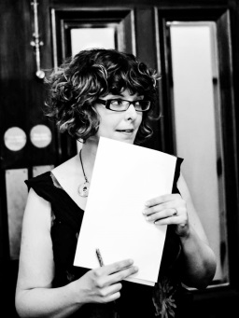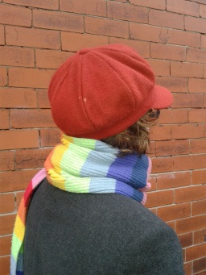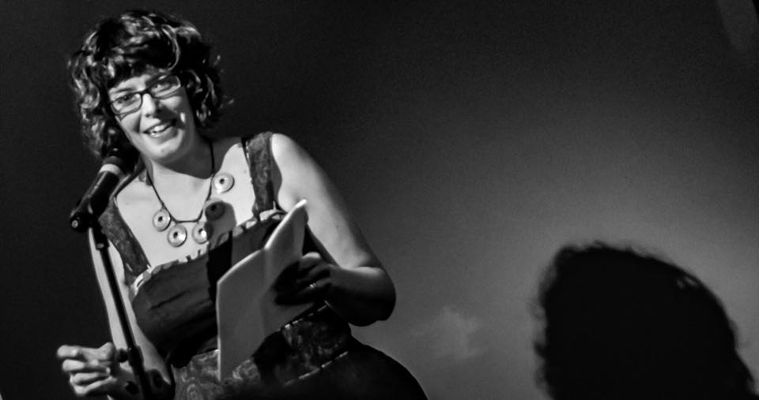

The Quiet Compere National Tour – Stop 9
The Phoenix Artist Club, Camden.

Sarah L Dixon, The Quiet Compere of Manchester, is taking her unique show on a National Tour in 2015. After the huge success of The Quiet Compere Tour of the North in 2014 she couldn’t stop there. Her tour will visit 12 more cities with over 120 different poets performing altogether.

The tour brings together a diverse selection of poets of all ages, cultures styles and experience, designed to entice an audience that may never have experienced spoken word events before. Sarah has been running spoken word events under her guise as The Quiet Compere for four years and ran a medical-themed poetry event at Cheltenham Poetry Festival in March 2014.

Quiet Compere events are unique. There are no lengthy introductions to poets, no-one is designated as ‘top-of-the-bill’ - all performers considered equal in Sarah’s eyes. Each line-up boasts a varied and diverse mix of poets, ranging from established local poets, some new to the scene who are ready to stun audiences with their talent, plus a generous sprinkling of nationally well-known poets and performers.

Camden Line-up

Zelda Chappel
Cathey Dreyer
Susan Evans
Lucy Furlong
Fran Isherwood
Laura McKee
Carolyn O’Connell
Joshua Seigal
Emma Simon
Jamie Spracklen

Tickets: http://www.wegottickets.com/event/330372

About Sarah L. Dixon
A piece about Sarah’s wedding in the style of a Post Mortem report was awarded the acpNews First Prize in Journalism 2007. She has been published in The Ugly Tree, Rain Dog, Yorkmix and Cahoodaloodaling. Sarah L Dixon worked for the NHS 18 years before she decided to channel her skills and considerable energy into corralling poets into some sort of order. Sarah not only promotes spoken word events, but offers regular writing workshops in the North-West, some of which are aimed specifically at hard-pressed parents of young children – of which she herself happens to be one.

Praise for Sarah L. Dixon
“Sarah's creative energy and enthusiasm are legendary. She encourages and gives a platform to fellow poets. Where would we be without her?”
- Carole Bromley, Poet and editor of Yorkmix

”Quiet Compere nights have a rare and lovely gentleness.”
- John Darwin, Host of Write Out Loud, Sale, Manchester

“You set a little powder keg under the palm tree and encourage the evening’s castaways to light the fuse. It’s perfect. You’re terrific. You do a lovely job. My, but you work so hard and affectionately at this game of the imagination.’
- Adrian Mealing, The Very Grimm Brothers.

For more Information please contact Sarah L Dixon, The Quiet Compere at thequietcomperemcr@gmail.com Follow on Twitter @QuietCompereMCR or call on 07743685221

Quiet Compere National Tour 2015
The Quiet Compere Tour is supported using public funding by the National Lottery through Arts Council England.

Date City Venue
Thursday 5th March Halifax Bar Up
Friday 27th March Durham The Old Cinema Laundrette
Friday 15th May Chesterfield Chesterfield Labour Club
Saturday 16th May Oxford Albion Beatnik Bookshop
Friday 26th June Ulverston Bardsea Malt Kiln
Friday 10th July Worcester The Hive
Friday 4th September Hull Union Mash-up
Saturday 12th September Exeter Exeter Phoenix - Voodoo Lounge
Tuesday 13th October London 1 Phoenix Artist Club, Camden
Wednesday 14th October London 2 Hackney Attic
Thursday 15th October Norwich The Bird Cage
Friday 20th November Cheltenham The Strand Hotel

